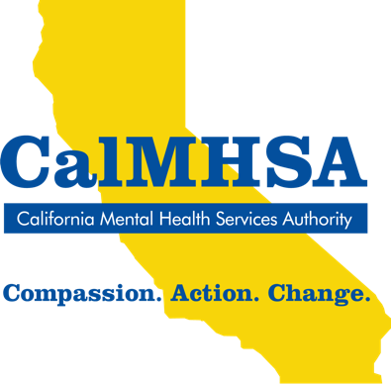
Media Contact:
Padma Nagappan
Padma@Civilian.com
Cell: (858) 324-5322

Check In, Seek Support During Mental Health Matters Month in May

The month of May is about improving our mental health awareness, recognizing signs, and learning when to seek support.

Sacramento, Calif. – May 1, 2022 – Our mental health deserves the same attention as our physical health but is far too often overlooked or ignored. This month, during May is Mental Health Matters Month, there’s renewed focus on the actions we can take in our county/city to support our own mental health and the mental health of people we care about. There’s no better time than now to attend to our mental health needs.

More than half of all Americans experience a mental illness or disorder in their lifetime. In recent years, stress, depression and anxiety have become much more common due to the pandemic, social isolation, and transitions back to school and work. But it can be difficult to know what to do when we or our family, friends, or peers experience these feelings.
The recently launched Take Action for Mental Health statewide campaign builds on established approaches and provides resources to equip all Californians to support their own mental health and the mental health of people they care about.

The Take Action for Mental Health campaign focuses on three key actions—check in, learn more, and get support:
- Check in: Check in on your mental health and the mental health of those you care about. Start a conversation to see how you can help or support yourself or others.
- Learn more: Learn more about mental health needs and explore the self-care, services, and supports available to help find a path forward.
- Get support: Get support for yourself or someone you care about by reaching out and connecting with tools and resources available in your community.

Join people across California this May in making and sharing your personal Pledge to Take Action for Mental Health. By making this Pledge, you are committing to Check In, Learn More, and Get Support for yourself, your friends, and your community to support one another’s mental health.
The Take Action for Mental Health Pledge says:
I Pledge to Take Action for Mental Health
- I will Check In with myself to identify mental health needs.
- I will Learn More about mental health.
- I will Get Support for my own mental health and support the mental health of others.
- I will share this pledge with others to help them take action too!

About CalMHSA
The California Mental Health Services Authority (CalMHSA), in collaboration with its county members, is a leading voice for mental health services for California. Created to deliver on the promise of the California Mental Health Services Act, CalMHSA is an independent government agency created by California counties and cities, focused on the efficient delivery of mental health services and resources.

The Mental Health Services Act (MHSA) Prevention and Early Intervention (PEI) component was designed to increase awareness of and access to mental health services, reduce the negative impacts that mental illness can have on a person’s wellbeing, reduce the stigma associated with mental illness and help-seeking, and prevent suicide.

###

[NOTE: Insert your County/Agency to customize.]

